Analysis of Amazon Books
Q1. Categorize the 550 books to fiction and non-fiction.
Answer:
i. select name, genre from amazon_csv where genre = 'Fiction';
ii. select name, genre from amazon_csv where genre = 'Non Fiction;
iii. SELECT
name AS Title,
author, genre,
row_number() OVER (PARTITION BY genre) AS row
FROM Amazon_csv;

iv. select count(case when genre='Fiction' then 1 end) Fiction,
count(case when genre='Non Fiction' then 1 end) NonFiction
from [dbo].[Amazon_csv] group by genre;
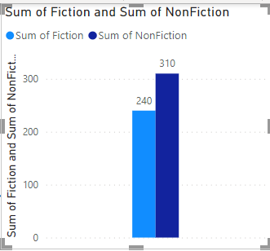

Observation :
Fiction count = 240
Non-Function = 310

Q2. Query the top 50 best sellers and show the following:
a. Title of Book
b. Author
c. Year
d. Review
Answer:
- select top(50) name, author, year,reviews from amazon_csv order by reviews desc;
- with cnt1(name, author,review,year) as
(
select top(50) name,author,reviews,Year from Amazon_csv order by reviews
)
select year, count(*) from cnt1 group by year;
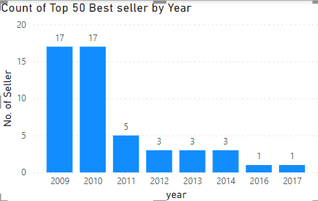
Observation:
* The range of top 50 reviews from 87841 to 26234
* Year includes 2010 to 2019
* Year excludes 2009

Q3. Query the books which have a rating greater than 4 released last 2019.
Answer:
- select name,user_rating, year from amazon_csv where user_rating>4 and year=2019;
2. with cnt2(name,user_rating,year) as
(
select name,user_rating, year from amazon_csv where user_rating>4 and year=2019
)
select user_rating, count(name) from cnt2 group by user_rating;
3. select avg(user_rating)from amazon_csv where user_rating>4 and year=2019;
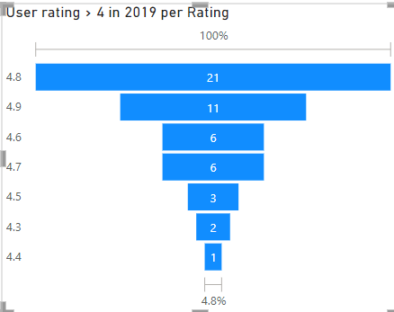
Observation:
* Total count rows have a rating >4 released in the year 2019=50
* Average rating in the year = 4.74

Q4. Query the books which have a rating greater than 4.5 in Fiction per year .
Answer:
select year, count(name) from Amazon_csv where genre='Fiction' and User_Rating >4.5 group by year;
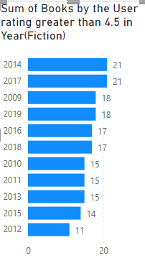

Q5. Query the books which have a rating greater than 4.5 in Fiction per year .
Answer:
select year, count(name) from Amazon_csv where genre='Non Fiction' and User_Rating >4.5 group by year;

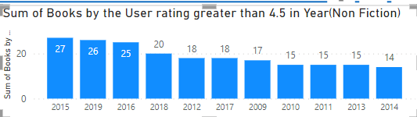

Q6. Sum of Reviews per year
Answer:
select year, sum(reviews) from Amazon_csv group by year;

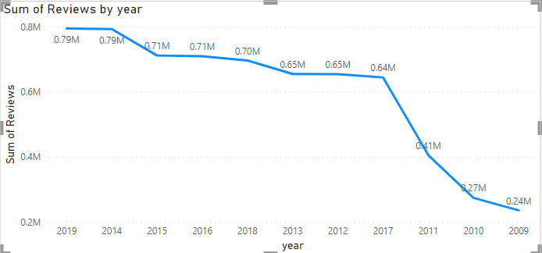
Year Sum of Reviews
2009 | 235506
2010 | 273981
2011 | 405041
2012 | 654546
2013 | 654907
2014 | 792997
2015 | 711669
2016 | 709800
2017 | 644420
2018 | 696521
2019 | 794917

Q7. Number of Titles with reviews < 10K per year
Answer:
select year, count(name) from Amazon_csv where reviews <1000 group by year;

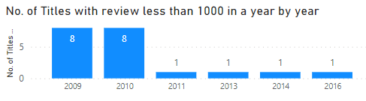

Q8. Number of Titles with reviews < 10K per year
Answer:
select year,count(name) from Amazon_csv where price between 10 and 15 group by year;

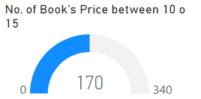

Q9. Number of Titles with reviews < 10K per year
Answer:
select year, count(name) from Amazon_csv where reviews <5000 and price>15 and genre='Fiction' group by year;
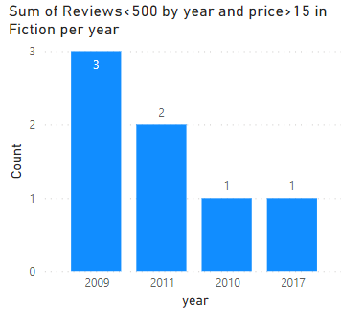

Q10. Number of Book with minimum reviews and minimum price per year
Answer:
select year, count(name) from Amazon_csv where reviews = (select min(reviews) from Amazon_csv) or Price=(select min(price) from Amazon_csv) group by year;

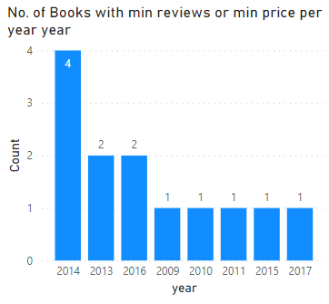

Q11. Number of Book with minimum price in Fiction per year
Answer:
select year, count(name) from Amazon_csv where Price=(select min(price) from Amazon_csv) and genre ='Fiction' group by year;

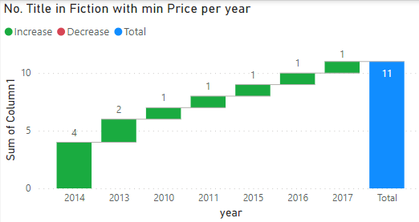

Q12. Number of Book with minimum price in Fiction per year
Answer:
select year,count(name) from Amazon_csv where price = any(select price from Amazon_csv where reviews=87841) group by year;

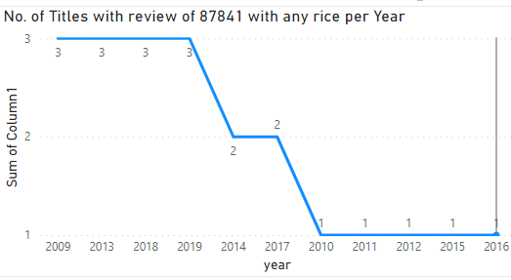

Q13. Total Book in Fiction per Year
Answer:
select year, count(genre) from Amazon_csv where genre ='Fiction' group by year;

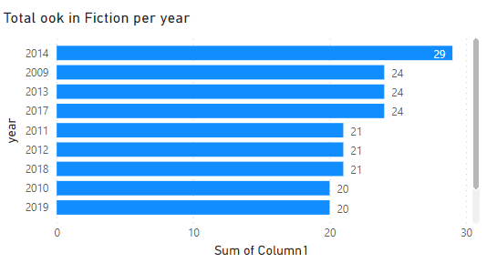

Q14. Total Book in Non Fiction per Year
Answer:
select year, count(genre) from Amazon_csv where genre ='Non Fiction' group by year;

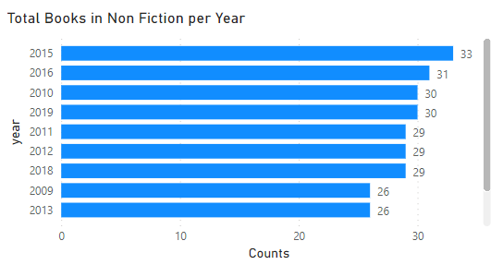

Q15. Total Book in Non Fiction per Year
Answer:
select year, count(name) from Amazon_csv where reviews = (select max(reviews) from Amazon_csv) or Price=(select max(price) from Amazon_csv) group by year;

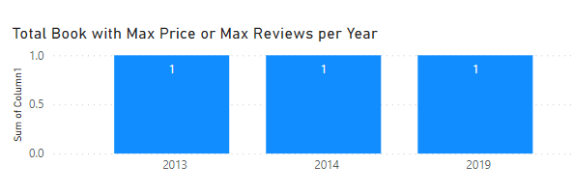
Observarion:
One book with Maximum reviews and price in 2013,14 and 19.

